Objective:

To take data on and visually represent velocities of a group of students as they run 16 meters through a hallway by means of a position vs time graphs.

Materials:

1. Meter stick
2. Tape
3. Stop watch
4. Laptop

Procedure:

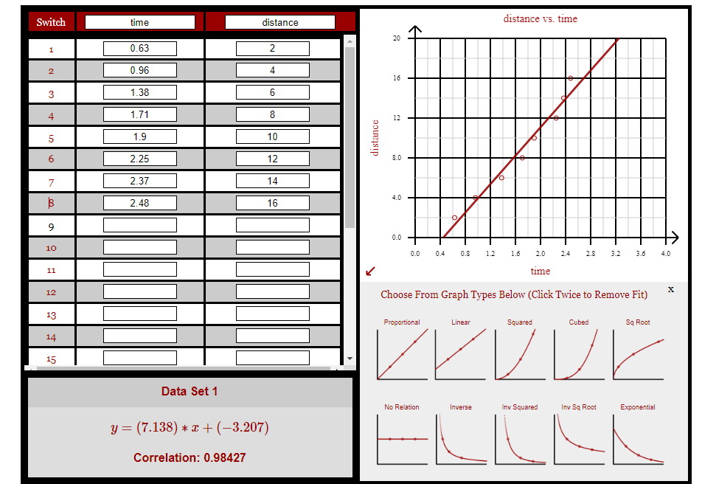

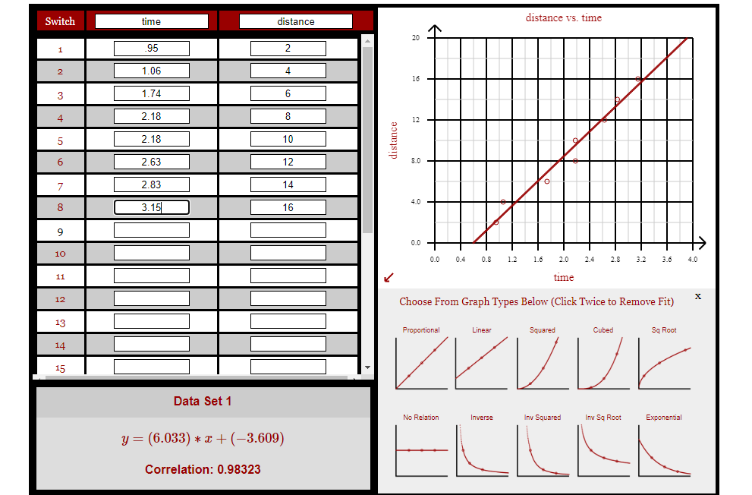

Conclusion:

The fastest student was student number 1, having an average velocity of 7.138m/s. The greatest maximum instantaneous velocity was calculated to be infinite, as student number 8 was recorded as being at 2 positions at the same time. There are two main sources of error to account for in this lab. The first is different reaction times between individual timers. Another source of error is humans do not have perfectly constant velocities, so the best fit line does not accurately represent their true acceleration and velocity.